13 December 2025
Dearest family and friends
As the end of 2025 approaches I wanted to extend my sincere wishes to you all for the imminent festive season and the New Year which will follow. I sincerely hope that you will remain safe and secure and that you will have the opportunity to celebrate with all your loved ones.


And I also have some very good news for you. I have secured a surgery date of 17 December for my stoma reversal. Forgive me for not being at the ‘end of the phone’ during my initial recovery but you’re welcome to send messages. 2025 has been a tumultuous year for me – for myriad reasons that you will know all too intimately – and so to have this final process concluded in the year is extremely important for me. Of course, I won’t be able to ‘celebrate’ the festive season but I will do my best.
So, Goodbye ‘Bag’.
And that’s not all the good news!
After the expected successful recovery from my stoma closure, I intend to continue to offer cover teaching at New Zealand Language Centres. This is the same school at which I have been doing some relief teaching; they seem to like me and I’m sure they’ll try and accommodate my request. The pictures below show the teachers at the school celebrating their 40th anniversary and one of my classes from 2025.
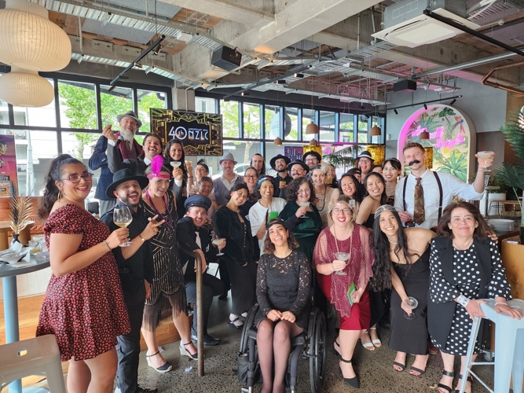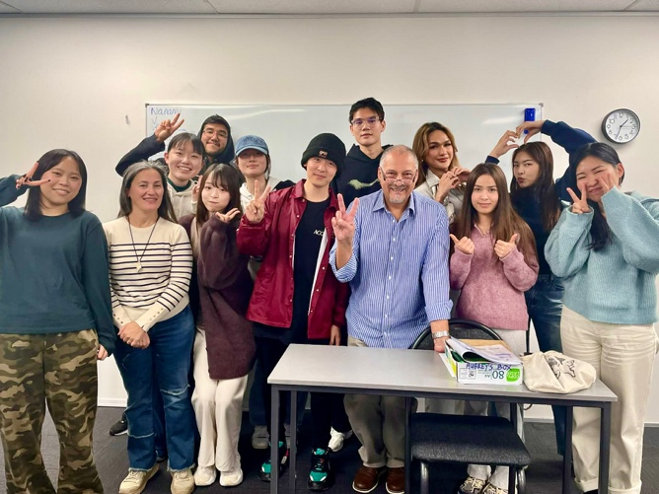

It’s been three years since The Eagle (my mother) passed away leaving me the only remaining member of my nuclear family alive. I still miss her every day just as I miss all the family and friends I have lost in my life. Over recent years, I have done my very best to support and take care of those who have been a part of my life, also distributing my wealth to the younger members of my extended family.
The world is a very unhappy place at present what with several catastrophic wars being fought on multiple fronts, hundreds of millions being displaced from their homes, the rich getting richer while the numbers in poverty continue to grow, the massive loss of jobs which will result as AI takes over employment—all of these are challenges which face future generations. As individuals, most of us have no hope of mitigating or resolving these challenges—so just do the best you can for those around you. You can bring joy, hope and a better day for many people you come across so act with kindness and empathy.
So, “sweeties daaahlings” - have a lekker time over Kristmas!
love, Aubrey

Happy Holidays and Happy New Year!

